Unit 13 Assignment Instructions – CIS164 
For the Unit 13 Assignment we will be working with scheduling programs and opening applications on your system, which provides a great source for automation!
Please make sure to fully read each question to ensure that you answer each question per the requirement. Also, please ensure that all responses are in complete sentences, free of spelling and grammatical errors.
*Unit 13 Grading Rubric (45 Points):
Assignment Requirements | Maximum Points | Points Earned
1. Working with Time | 0-20 Points
2. Open Websites with Multithreading | 0-25 Points
Points Deducted for Spelling or Grammatical Errors
Total (Sum of All Points)
*Directions for Submitting Your Assignment:
Complete your assignment ensuring all questions are answered based on the assignment requirements. When the Unit 13 assignment is complete, please save your file in the following format, “Lastname-Unit#.doc” (Example: Smith-Unit13.doc). You may also utilize a Word Processing software such as LibreOffice for assignment completion. In this case the assignment may be saved in .odt format, (Example: Smith-Unit13.odt). Then when ready submit your file to the “CIS 164 – Unit 13 Submit Assignment” activity for grading.

1. Working with Time
- Start the PyCharm IDE. Select “File->New Project” on the next screen, ensure “Pure Python” is highlighted. Then under “Location” change the word “untitled” to “Unit13”. Then click the “Create” button.

- Highlight your project “Unit13” then right click. When you right click a menu will appear, from this menu select New->Python File. Then a dialog box will appear, in the “Name” field of the dialog box type “Time1.py”.

- Create a Python script with a function named ‘timeReporting’ that accepts one parameter value. The parameter value will be an integer that is used for the time.sleep() method.

- Your function when called in the main portion of your script will need to print out, similar to the following, but with your current date and time being shown, utilizing the Python libraries introduced in the Chapter reading:

The Current Date is: 10/01/2017
The Current Time is: 08:00:00
***Insert pause here***
The Current Date is: 10/01/2017
The Current Time is: 08:00:05

Provide a screenshot of your script’s output when run, and provide your code within this document copied and pasted from your file.

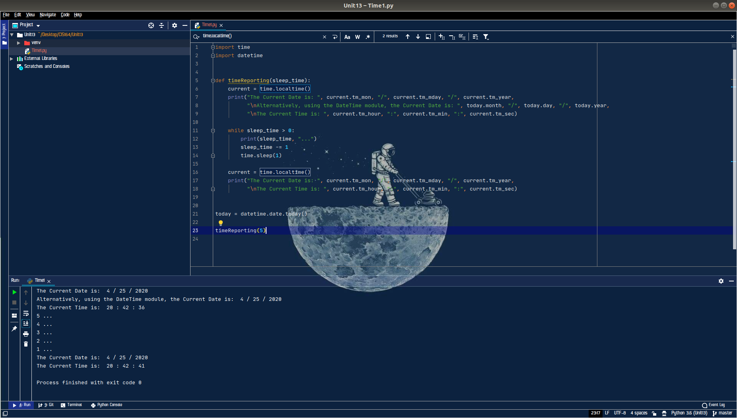

2. Open Websites with Multithreading
- Highlight your project “Unit13” then right click. When you right click a menu will appear, from this menu select New->Python File. Then a dialog box will appear, in the “Name” field of the dialog box type “Interact1.py”.

- Create a python script with a function named openWebsite. The function will have no parameters. For the function you will use the webbrowser library to open the following webpages:

https://xkcd.com/210/
http://xkcd.com/1303/
https://xkcd.com/1309/
https://xkcd.com/1349/
https://xkcd.com/1373/
http://xkcd.com/1742/
https://www.cochise.edu/

- In the main portion of your script, you will use the threading library to call your function, openWebsite, using multithreading.

- Provide a screenshot of your script’s output when run, and also provide your code within this document copied and pasted from your file or in a text file accompanying this document.

